NAME:ADAN SAUD
ROLL#:2026-CYS-293

LAB:AICT (CLO-1)

SUBMITTED TO:MAM KANWAL

Sports Gala 2026
UET LAHORE CS DEPARTMENT
GEAR UP FOR THE MOST EXCITING EVENT



MARCH 31,2026
IQBAL STADIUM

References:

1)  2)  3)  4)  5)  6)  7 )  8)  9)  10)  11)  12)  13)  14)  15)  16) | A., B. (n.d.). Basic Mathematics. Retrieved May 5, 2019, from http://Basic mathematics.org.uk.get  johns, S. (n.d.). Computer basics. Retrieved August 3, 2020, from http://Computer basics.org.uk.get  M., J. (n.d.). Digital Technology. Retrieved May 8, 2013, from http://Digital technology.org.uk.get  MillerT. (n.d.). Application in education . Retrieved May 5, 2017, from http://Applications in education.org.uk.get  WilliamR. (n.d.). Learning python programming. Retrieved April 5, 2010, from http://Learning python programming.org.uk.get  George orwell. (n.d.).Basics of digital litearacy. Retrieved May 5, 2019, from http:// Basics of digital litearacy.org.uk.get  johns, S. (n.d.). Computer basics. Retrieved August 3, 2020, from http://Computer basics.org.uk.get  Thomas T.. (n.d.). Digital Technology. Retrieved May 8, 2013, from http://Digital technology.org.uk.get  MillerT. (n.d.). pride and prejudice . Retrieved May 5, 2017, from http:// pride and prejudice.org.uk.get  WilliamR. (n.d.). Learning python programming. Retrieved April 5, 2010, from http://Learning python programming.org.uk.get  Emile Bronte. (n.d.). Basic Mathematics. Retrieved May 5, 2019, from http://Basic mathematics.org.uk.get  johns, S. (n.d.). . Retrieved August 3, 2020, from http:// pride and prejudice.org.uk.get  M., J. (n.d.). Digital Technology. Retrieved May 8, 2013, from http://Digital technology.org.uk.get  Emile Bronte.. (n.d.). Application in education . Retrieved May 5, 2017, from http://Applications in education.org.uk.get  WilliamR. (n.d.). Learning python programming. Retrieved April 5, 2010, from http://Learning python programming.org.uk.get  ThomasR. (n.d.). Basics of digital litearacy. Retrieved April 5, 2010, from http:// Basics of digital litearacy.org.uk.get  WilliamS. (n.d.). George Orwell. Retrieved April 5, 2010, from http:// George orwell.org.uk.get
KINDERGARTEN STUDENT ACTIVITIES:
Here are some fun and engaging activities designed for kindergarten students to help them to learn, play and grow in a creative environment
- Story Time:  Reading colourful picture, glue and scissors to create simple crafts like animals, flowers, or shapes to boost creativity and fine motor skill | 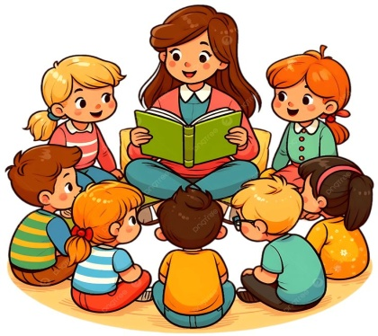
- Arts and Crafts:  Using paper , crayons glue and scissors to create simple crafts like animals ,flowers or shapes to boost creativity and fine motor skills. | 
- Sing-Along and Dances:  Singing nursery rhythms and dancing to fun tunes to improve memory,rhythm, and coordination | 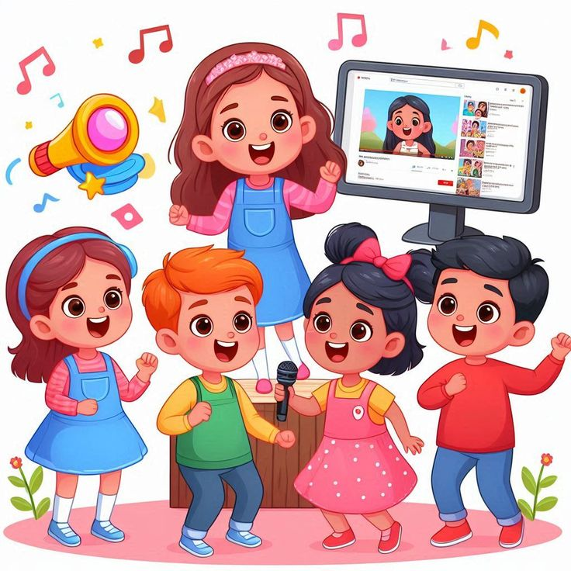
- Outdoor play:  Engaging in activities like running, ball games, or hopscotch to encourage physical development and teamwork | 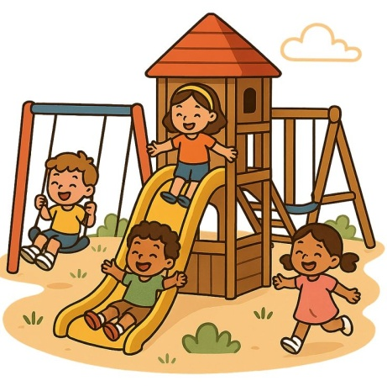
- Puzzle Play:  Solving simple jigsaw puzzles or shape-matching games to develop problem –solving and thinking skills. | 